Assignment

Day 10

Monday, 17 September 2023

SV G2 / Intake #3

By: Ibrahim Tarek

**Table of Contents**

1. Executive Summary 3

2. DMA Features 4

2.1. Advantages of DMA Controller 4

2.2. Disadvantages of DMA Controller 5

3. Configurations to be done with DMA driver 6

3.1. Workflow 6

4. References 7

# Executive Summary

**This report discusses each of the following topics:**

1. DMA Features.
2. Configurations to be done with DMA driver.

# DMA Features

Direct Memory Access uses hardware for accessing the memory, that hardware is called a DMA Controller. It has the work of transferring the data between Input Output devices and main memory with very less interaction with the processor. The direct Memory Access Controller is a control unit, which has the work of transferring data.

DMA Controller is a type of control unit that works as an interface for the data bus and the I/O Devices. As mentioned, DMA Controller has the work of transferring the data without the intervention of the processors, processors can control the data transfer. DMA Controller also contains an address unit, which generates the address and selects an I/O device for the transfer of data. Here we are showing the block diagram of the DMA Controller.

The figure below shows the block diagram of the DMA controller. The unit communicates with the CPU through the data bus and control lines. Through the use of the address bus and allowing the DMA and RS register to select inputs, the register within the DMA is chosen by the CPU. RD and WR are two-way inputs. When BG (bus grant) input is 0, the CPU can communicate with DMA registers. When BG (bus grant) input is 1, the CPU has relinquished the buses and DMA can communicate directly with the memory.

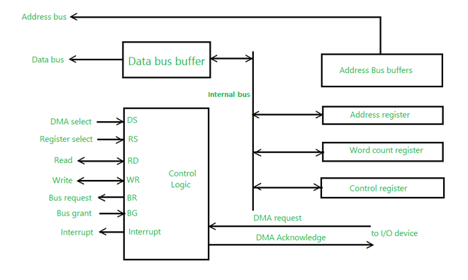

# Advantages of DMA Controller

* Data Memory Access speeds up memory operations and data transfer.
* CPU is not involved while transferring data.
* DMA requires very few clock cycles while transferring data.
* DMA distributes workload very appropriately.
* DMA helps the CPU in decreasing its load.

# Disadvantages of DMA Controller

* Direct Memory Access is a costly operation because of additional operations.
* DMA suffers from Cache-Coherence Problems.
* DMA Controller increases the overall cost of the system.
* DMA Controller increases the complexity of the software.

# Configurations to be done with DMA driver

This is the quick start guide for the DMA driver, with step-by-step instructions on how to configure and use the driver in a selection of use cases.

# Workflow

* + 1. Define the DMA channel that will be used for the transfer for convenience.
    2. Define the array length that will be the used for the source and destination buffers located in RAM.
    3. Create a pair of global arrays that will hold the source and destination data copied by the DMA controller channel when it is triggered.
    4. Create a function dma_init() to intialize the DMA.
    5. Create config struct for DMA channel.
    6. Make sure the configuration structure is zeroed out to ensure that all values are reset to their defaults before writing new values.
    7. Configure the DMA channel for single byte bursts, with a transfer length equal to the size of the source and destination buffers.
    8. Configure the DMA channel to reset the source and destination addresses at the end of the complete transaction (i.e. after DMA_BUFFER_SIZE bytes copied).
    9. Configure the DMA channel to increment the source and destination addresses after each byte transferred.
    10. Configure the DMA channel source and destination addresses.
    11. Enable the DMA module so that channels can be configured in it.
    12. Write the DMA channel configuration to the DMA and enable it so that it can be triggered to start the transfer.
    13. Initialize the clock system.
    14. Call our DMA init function.

# References

* 1. <https://www.geeksforgeeks.org/direct-memory-access-dma-controller-in-computer-architecture/>
  2. https://asf.microchip.com/docs/latest/xmega.drivers.dma.example.xplain/html/xmega_dma_quickstart.html